# VISVESVARAYA TECHNOLOGICAL UNIVERSITY,

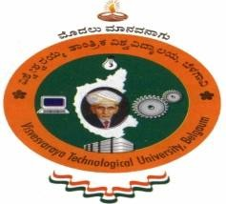**BELGAVI – 590 018**

## A MINI PROJECT REPORT

### ON

“BELLA AN AI CHATBOT”

Submitted in partial fulfillment of requirements of 6th semester of Bachelor of Engineering (B.E) course during the year 2023-2024.

***Submitted by***

### FARHAN (3GN21CS030)

### MD HUZAIF SHAH (3GN21CS038)

### MD ADIL ALI (3GN21CS037)

***Under the Guidance of***

### Prof. Ashwini M

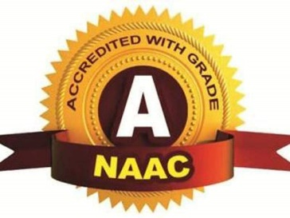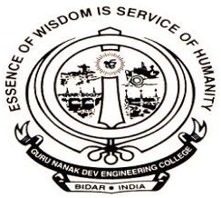

##### DEPARTMENT OF COMPUTER SCIENCE & ENGINEERING

##### GURU NANAK DEV ENGINEERING COLLEGE, BIDAR

**ACADEMIC YEAR 2023-2024**

## GURU NANAK DEV ENGINEERING COLLEGE, BIDAR



**DEPARTMENT OF COMPUTER SCIENCE & ENGINEERING**

**CERTIFICATE**

This is certified that the mini project work entitled “BELLA AN AI CHATBOT” is a bonafide work carried out by FARHAN **(3GN21CS030)** in partial fulfillment of the requirements of the requirements for the award of Degree Bachelor of Engineering in **COMPUTER SCIENCE & ENGINEERING by** **VISVESVARAYA TECHNOLOGICAL UNIVERSITY, BELAGAVI** during the year **2023-2024.** The mini project report has been approved as it satisfies the academic requirements in respect of mini project work prescribed for the Bachelor of Engineering Degree.

**Prof. Ashwini M Dr. Savitri N Dr. Anuradha A**

GUIDE COORDINATOR HOD, CSE

NAME OF EXAMINER SIGNATURE WITH DATE

………………………… ……………………………

## ACKNOWLEDGEMENT

I would like to express my deep sense of gratitude to our principal **Dr. Suresh R Reddy** Guru Nanak Dev Engineering College, Bidar for his inspiration and academic support by providing good facilities to complete the mini project.

My sincere thanks to**, Dr. Anuradha A** Head of **Computer Science & Engineering** for his whole hearted support in completion of this mini project.

I am highly indebted to my mini project coordinator **Dr. Savitri N** for guiding and giving me timely advice and suggestions in the successful completion of the mini project.

I am highly indebted to my mini project guide **Prof. Ashwini M** for guiding and giving me timely advice and suggestions in the successful completion of the mini project.

I thank all the staff members for supporting me in completion of the mini project. Also, I am thankful to my parents and all my dear friends who have directly or indirectly helped me.

Finally, I express gratefulness to all those who knowingly or unknowingly helps me in successful completion of this mini project.

**FARHAN**

**(3GN21CS030)**